ID BR001

Product Name: www.evozon.com

**Summary:** The user cannot create account in the applications Magento page

**Description:** When the user clicks on https://magento.evozon.com., goes to the register page, and wants to create an account, an error appears, the page is not found.

**Steps:**

1. Navigate to [www.evozon.com](http://www.evozon.com)
2. Hover over Services
3. Click on Eccommerce System
4. Click on Magento Commerce from left side menu
5. Click on “here” clickable link from text
6. Click on Account
7. Click on Register

**Expected results:** After clicking on account the user should be redirected to the account page to where he can create his own account

**Actual results:** After clicking on account an error message is shown

**Screenshot:** 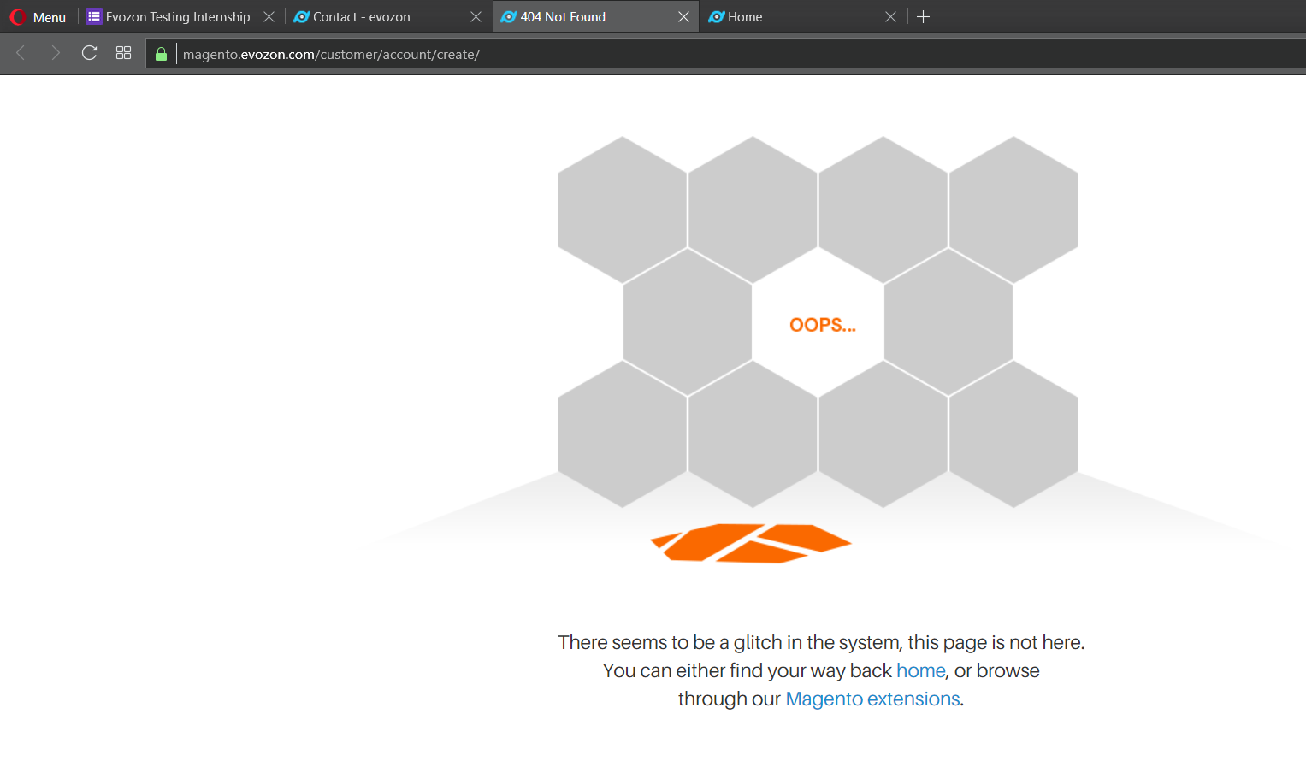

**Severity:** Blocker

**Browsers:** Chrome, Opera

**OS:** Windows 8

ID BR002

Product Name: www.evozon.com

**Summary:** Clicking on email link does not open email window

**Description:** When the user tries to click on an email link, that should open an application for writing and managing emails (e.g.: Microsoft Outlook), the link does not lead to the app itself, instead it only shows that the email link is correct.

**Steps:**

1. Navigate to www.evozon.com
2. Click on “Contact” button
3. Click on blue, clickable link [sales@evozon.com](mailto:sales@evozon.com)

**Expected results:** A new window should open, prefilled with users’ email and with the receivers’ email address, ready to be completed and sent

**Actual results:** The application doesn’t open, instead [mailto..sales@evozon.com](mailto:mailto..sales@evozon.com) appears in the left corner of the window browser

**Screenshot:**

**Severity:** Trivial

**Browsers:** Chrome, Opera

**OS:** Windows 8

**Comment:** When replicated in Opera browser the email application opens allowing the user to send the email.

ID BR002

Product Name: www.evozon.com

**Summary:** File uploading text field is misleading

**Description:** When the user goes to the Contact form the attachment field gives the impression that the user can write in it. After clicking on it opens directory in your computer. This bug is misleading, it looks like a text field, but does not impede the user from uploading an attachment.

**Steps:**

1. Navigate to www.evozon.com
2. Click on “Contact” button
3. Click on Attachment field

**Expected results:** The field looks like a text input field

**Actual results:** After clicking on the field, it opens a directory for the user to able to upload an attachment

**Screenshot:** 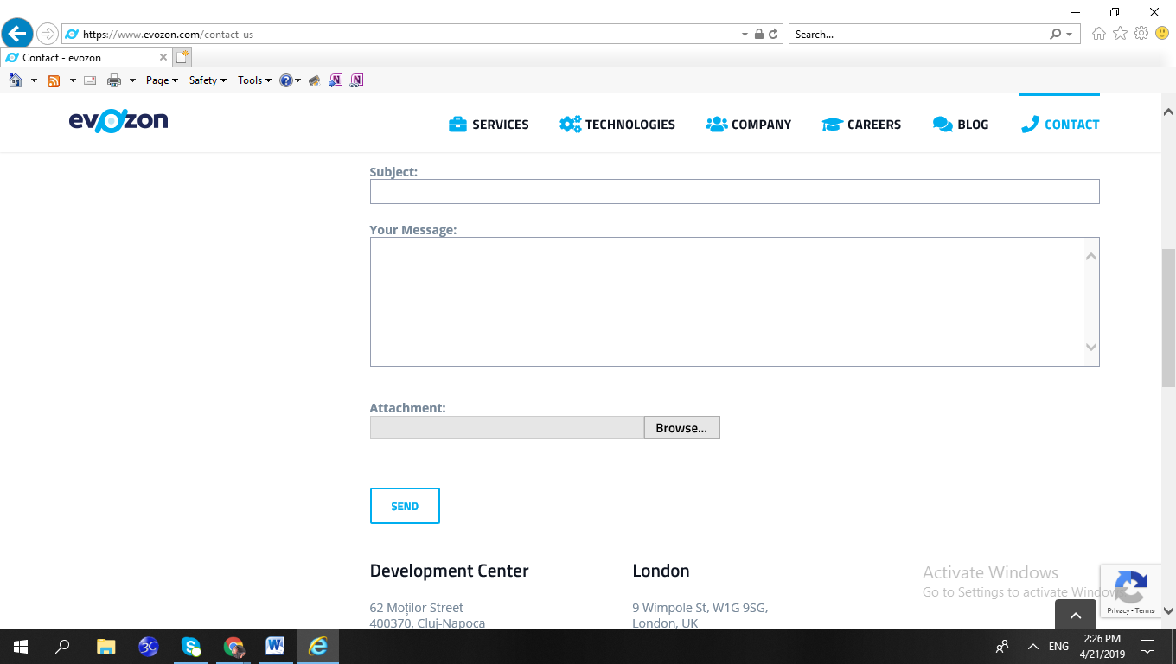

**Severity:** Trivial

**Browsers:** Internet Explorer

**OS:** Windows 8

**Comment:** The actual result is correct, it behaves as intended, that is why the bug is trivial, it is only misleading for the user.